Name: | Index No.: | CT Group: 09

PIONEER JUNIOR COLLEGE, SINGAPORE

JC2 PRELIMINARY EXAMINATIONS
HIGHER 2

CHEMISTRY 9647/03
9746/03

Paper 3 Free-Response 15 September 2010

2 hours
Candidates answer on separate paper.

Additional Materials: Writing Papers
Data Booklet
Cover Page

READ THESE INSTRUCTONS FIRST

Write your Centre number, index number and name on all work you hand in.
Write in dark blue or black pen on both sides of the paper.
You may use a soft pencil for any diagrams, graphs or rough workings.
Do not use staples, paper clips, highlighters, glue or correction fluid.

Answer any four questions.
A Data Booklet is provided.
You are reminded of the need for good English and clear presentation in your answers.

The number of marks is given in brackets [ ] at the end of each question or part question.
At then end of the examination, fasten all your work securely together.

This document consists of 10 printed pages.

Pioneer Junior College
Answer any four questions.

1 | (a) | Sulfuric acid, H₂SO₄, is a strong mineral acid which is an important chemical used in industry and in the school laboratory.  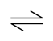  One step in the manufacture of sulfuric acid by the Contact Process involves the reaction between sulfur dioxide and oxygen.  2SO₂(g) + O₂(g) 2SO₃(g) ΔH = −197 kJ mol⁻¹  The reaction is carried out at a temperature of 450 ºC in the presence of a catalyst.
 |  | (i) | Explain why a temperature of 450 ºC is usually employed for the reaction.
 |  | (ii) | When a 2:1 ratio of SO₂ and O₂ at a total initial pressure of 1.5 atm is passed over a catalyst at 450 ºC, the percentage conversion of SO₂ into SO₃ was found to be 94%.  Calculate the equilibrium partial pressures of SO₃, SO₂ and O₂ and hence find the value for K_{p}.
 |  | (iii) | State and explain the effect on the percentage conversion of SO₂ into SO₃ when the volume of the reaction vessel is reduced.  [6]
 | (b) | Concentrated sulfuric acid is also an important reagent in many organic reactions where it can perform roles such as an acid, dehydrating agent or a catalyst as illustrated in the following reaction scheme.  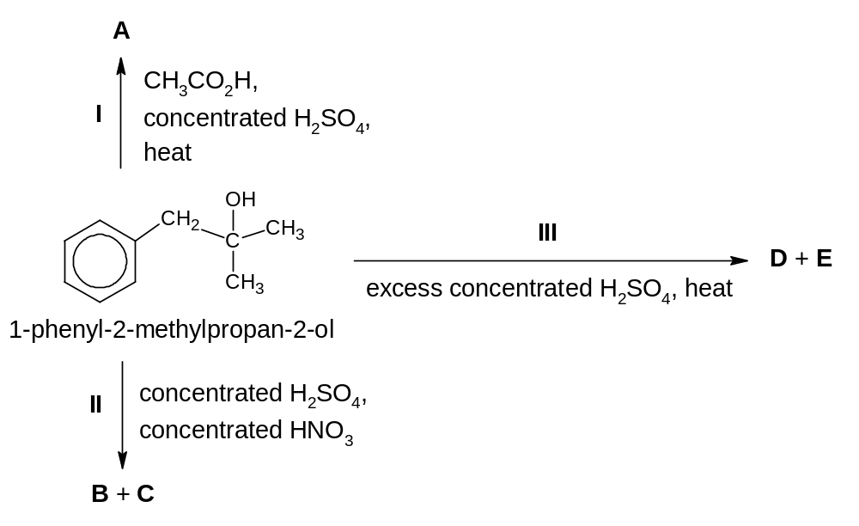
 |  | (i) | Give the structural formulae of the compounds A to E.
 |  | (ii) | The first step in reaction II is the generation of an electrophile, NO₂⁺. Using NO₂⁺ as an example, explain the term electrophile.
 |  | (iii) | By means of an equation, explain the role of concentrated H₂SO₄ during the generation of the electrophile, NO₂⁺, for reaction II.
 |  | (iv) | Unlike 1-phenyl-2-methylpropan-2-ol, phenol undergoes reaction II, without the need for concentrated H₂SO₄. Explain why this is so.  [8]
 | (c) | Lactic acid is the major acidic component of soured milk and it has the following structure.  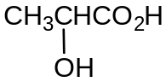  On reduction, lactic acid is converted to K, C₃H₈O₂. K, on passing its vapour over hot Al₂O₃, gives compound L, C₃H₆O.  L gives no reaction with 2,4-dinitrophenylhydrazine but decolourises aqueous bromine. When L is treated with hot acidified KMnO₄, it gives carbon dioxide gas as the only carbon-containing product.
 |  | (i) | Suggest a reducing agent to convert lactic acid to compound K.
 |  | (ii) | Deduce the structures of compounds K and L, and explain the above reactions.  [6]  [Total:20]
2 | (a) | A cell consisting of two half-cells is used to power an electrolysis reaction.  The cell contains aqueous sodium hydroxide as the electrolyte with graphite as the electrodes. The reactants are hydrogen and oxygen gases.
 |  | (i) | Draw a labelled diagram to show how you would measure the standard cell potential, E^{θ}_{cell}, of the cell. Indicate the direction of electron flow in your diagram.
 |  | (ii) | Write the half-equations for the reactions taking place at the anode and cathode. Hence, calculate the E^{θ}_{cell} of the cell.
 |  | (iii) | How will the E^{θ}_{cell} change when a small amount of acid is added to the electrode with oxygen gas?
 |  | (iv) | The temperature under which the electrolysis is being carried out is increased but a constant current is maintained. State how the rate of the electrolysis would change.  [9]
 | (b) | Astatine, At, the element below iodine in Group VII, is only produced in trace amounts. Use your knowledge of the halogens to predict the changes (if any) that you may observe when the following reagents are mixed. Where a reaction is predicted, write a balanced equation with state symbols.
 |  | (i) | Aqueous bromine and aqueous sodium astatide, NaAt.
 |  | (ii) | Aqueous silver nitrate and aqueous sodium astatide, followed by aqueous ammonia.
 |  | (iii) | Sodium astatide and concentrated sulfuric acid.  [7]
 | (c) | Outline the synthesis pathway to convert benzoic acid, C₆H₅CO₂H, to 2-phenylethanoic acid, C₆H₅CH₂CO₂H. Include any intermediates that are formed.  [4]  [Total: 20]
3 | (a) | Blood plasma is a biological fluid that plays an important role in maintaining pH in the body.  In the blood plasma, the equilibrium between carbonic acid, H₂CO₃(aq), and hydrogencarbonate ion, HCO₃⁻(aq), buffers pH changes.  H₂CO₃(aq) 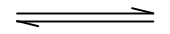 H⁺(aq) + HCO₃⁻(aq)  The K_{a} value for this equilibrium is 7.90 × 10⁻⁷ mol dm⁻³.  At body temperature, the pH of the arterial blood plasma is 7.40.  If the pH falls below this normal value, a condition termed acidosis is produced. If the pH rises above this normal value, the condition is termed alkalosis.  The concentration of H₂CO₃(aq) is controlled by respiration through the lungs.  H₂CO₃(aq) is in equilibrium with dissolved CO₂ as shown below.  H₂CO₃(aq) CO₂(aq) + H₂O(l)  In the lungs, excess dissolved CO₂(aq) is exhaled as CO₂(g).  CO₂(aq) CO₂(g)  During heavy exercise, lactic acid is released into the blood and is buffered by the blood plasma. This eventually leads to an increase in CO₂(aq) concentration and stimulates increased breathing.
 |  | (i) | Explain what is meant by a buffer solution.
 |  | (ii) | Write an expression for the acid dissociation constant, K_{a}, of H₂CO₃(aq) and use it to determine the [HCO₃⁻(aq)] / [H₂CO₃(aq)] ratio in the blood plasma.
 |  | (iii) | Write an equation to show how blood plasma can buffer the pH change when lactic acid is released into the blood.
 |  | (iv) | Explain why the rate of breathing increases when lactic acid is released into the blood during heavy exercise.  [6]
 | (b) | One way to test for CO₂ gas is to bubble it into limewater, Ca(OH)₂(aq). However, calcium hydroxide is only sparingly soluble.  An excess of solid calcium hydroxide is shaken in 0.010 mol dm⁻³ sodium hydroxide to reach equilibrium and then filtered. 25.0 cm³ of the filtered solution is required to neutralise 20.0 cm³ of 0.050 mol dm⁻³ hydrochloric acid.
 |  | (i) | Calculate the total hydroxide ion concentration in mol dm⁻³ in the solution.
 |  | (ii) | Calculate the concentration of hydroxide ions which is associated with the calcium ions.
 |  | (iii) | Calculate the concentration of calcium ions in mol dm⁻³ in the solution.
 |  | (iv) | Give the expression for the solubility product of calcium hydroxide and use your answer obtained from (i) to (iii) to calculate the solubility product of calcium hydroxide.  [6]
 | (c) | Lactic acid, glycolic acid and salicylic acid are three organic acids commonly used in chemical peel which is a body treatment technique used to improve and smoothen the texture of facial skin using a chemical solution that causes the dead skin to slough off and eventually peel off.  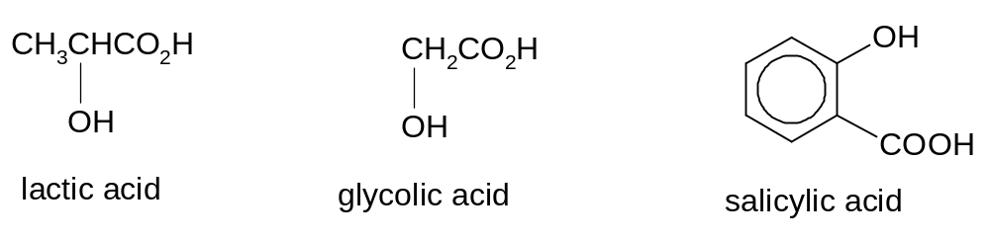
 |  | (i) | Suggest a simple chemical test that can be used to distinguish each of the following pairs.  - lactic acid from glycolic acid, and  - glycolic acid from salicylic acid.  You are not allowed to use the same reagents for both tests.  For each test, state the reagents and conditions, give the expected observations.
 |  | (ii) | Suggest how lactic acid can be synthesised from ethanol. Indicate reagents and conditions you would use for each step. Give the structural formulae of the intermediate compounds formed.
 |  | (iii) | When lactic acid is heated with concentrated sulfuric acid, compound M with molecular formula C₆H₈O₄ is obtained. Give the structural formula of compound M.  [8]  [Total: 20]
4 | (a) | (i) | State any two physical properties in which transition metals differ from those of a typical s-block element such as calcium.
 |  | (ii) | Describe the cobalt atom, ⁵⁹Co, as fully as you can, including the nature and location of the sub-atomic particles.
 |  | (iii) | Explain why cobalt can form variable oxidation states whereas calcium cannot.  [6]
 | (b) | When air is bubbled through an aqueous solution containing CoCl₂, NH₄Cl and NH₃, and the resultant solution is evaporated, crystals of a salt X are then isolated. X, which contains an octahedral complex ion, has the following composition by mass.  On adding an excess AgNO₃(aq) to a solution containing 0.01 mol of X, 1.43 g of AgCl(s) is precipitated. Only free chloride ion is able to be precipitated as AgCl(s). Chloride ion bound as ligand in the complex ion with cobalt cannot be precipitated.
  element | Co | N | H | Cl
  percentage by mass | 25.2 | 24.0 | 5.1 | 45.7
 |  | (i) | Calculate the empirical formula of X.
 |  | (ii) | Calculate the number of moles of AgCl precipitated.
 |  | (iii) | Each of the cobalt complex ions contains 6 ligands. Hence, deduce the structural formula of X.
 |  | (iv) | State the oxidation number of cobalt in X.  [6]
 | (c) | When aqueous ammonia is added gradually to aqueous cobalt(II) chloride, a blue precipitate is formed initially, but this dissolves in an excess aqueous ammonia to give a pale brown solution containing [Co(NH₃)₆]²⁺. On standing in air, the pale brown solution gradually turns darker brown. Explain the observations.  Standard electrode potential: [Co(NH₃)₆]³⁺ + e ⇌ [Co(NH₃)₆]²⁺ E^{ө} = +0.11 V  [4]
 | (d) | Chlorofluorocarbons, CFCs, are small alkane molecules in which some of the hydrogen atoms have been replaced by atoms of chlorine and fluorine. CFCs are used as aerosol propellant in spray can and refrigerant in refrigerator. A typical CFC is CHF₂CHClF.
 |  | (i) | CHF₂CHClF can be converted to CHF₂CH(OH)F. Give the reagents and conditions for this process. Explain why not all C-Hal bonds in this CFC undergo the above reaction.
 |  | (ii) | Why does this CFC present an environmental concern? Suggest one way to reduce the use of CFCs.  [4]  [Total: 20]
5 | (a) | Hydrazine, N₂H₄, has an ammonia-like odour and is derived from the same industrial chemical processes that manufacture ammonia. In some cases, hydrazine behaves like ammonia in chemical reactions. For example, hydrazine is able to form a product when it reacts with boron trifluoride, BF₃, in a molar ratio of 1:1.
 |  | (i) |  | Draw the ‘dot-and-cross’ diagram of a molecule of N₂H₄. Use the electron pair repulsion theory to predict the shape and state the H-N-H bond angle of this molecule.
 |  | (ii) |  | Draw a diagram to show the shape of the product formed when hydrazine reacts with BF₃, in a molar ratio of 1:1.  [3]
 | (b) | Ethene, C₂H₄, and hydrazine, N₂H₄, are hydrides of elements which are adjacent in the Periodic Table.  The boiling point of hydrazine is much higher than that of ethene. Account for this difference in terms of their structures and bondings. [2]
 | (c) | Hydrazine is used as rocket fuel. It can undergo combustion to produce nitrogen gas that can react in excess oxygen to produce nitrogen dioxide.  Nitrogen dioxide may undergo decomposition to produce nitrogen monoxide and oxygen.
 |  | (i) |  | Write a balanced equation, with state symbols, for the decomposition of one mole of nitrogen dioxide.
 |  | (ii) |  | Given that the ΔS^{θ} for the decomposition of nitrogen dioxide is +73.3 J mol⁻¹ K⁻¹, explain the significance of the sign.
 |  | (iii) |  | The standard enthalpy change of formation, ΔH_{f}^{θ}, of NO₂(g) and NO(g) are as follows:  Determine the feasibility of the decomposition of nitrogen dioxide at 298 K.  [5]
   | NO(g) | NO₂(g)
  ΔH_{f}^{θ} / kJ mol⁻¹ | +90.2 | +33.2
 | (d) | P, C₁₁H₁₄O, dissolves sparingly in water. Q, C₁₁H₁₂OBr₄, is formed as a minor product when aqueous bromine is added to P. The solution decolourises and a white precipitate is formed. When heated with acidified potassium manganate(VII), P gives R, C₄H₈O, and S, C₇H₆O₃.  R produces an orange precipitate when reacted with 2,4-dinitrophenylhydrazine. R also gives yellow precipitate when treated with aqueous alkaline iodine.  S shows similar observations as P when it is treated with aqueous bromine. 2 moles of S reacts with 1 mole of sodium carbonate while 1 mole of S reacts with sodium metal to produce 1 mole of hydrogen gas. S reacts with phosphorus pentachloride to form T.  Deduce the structural formulae of P, Q, R, S and T. Explain your reasoning and the chemistry of the reactions involved. [10]  [Total: 20]

